Eric Ong (861267345)

Thomas Chin (861290572)

Section 002

CS014 Homework #2

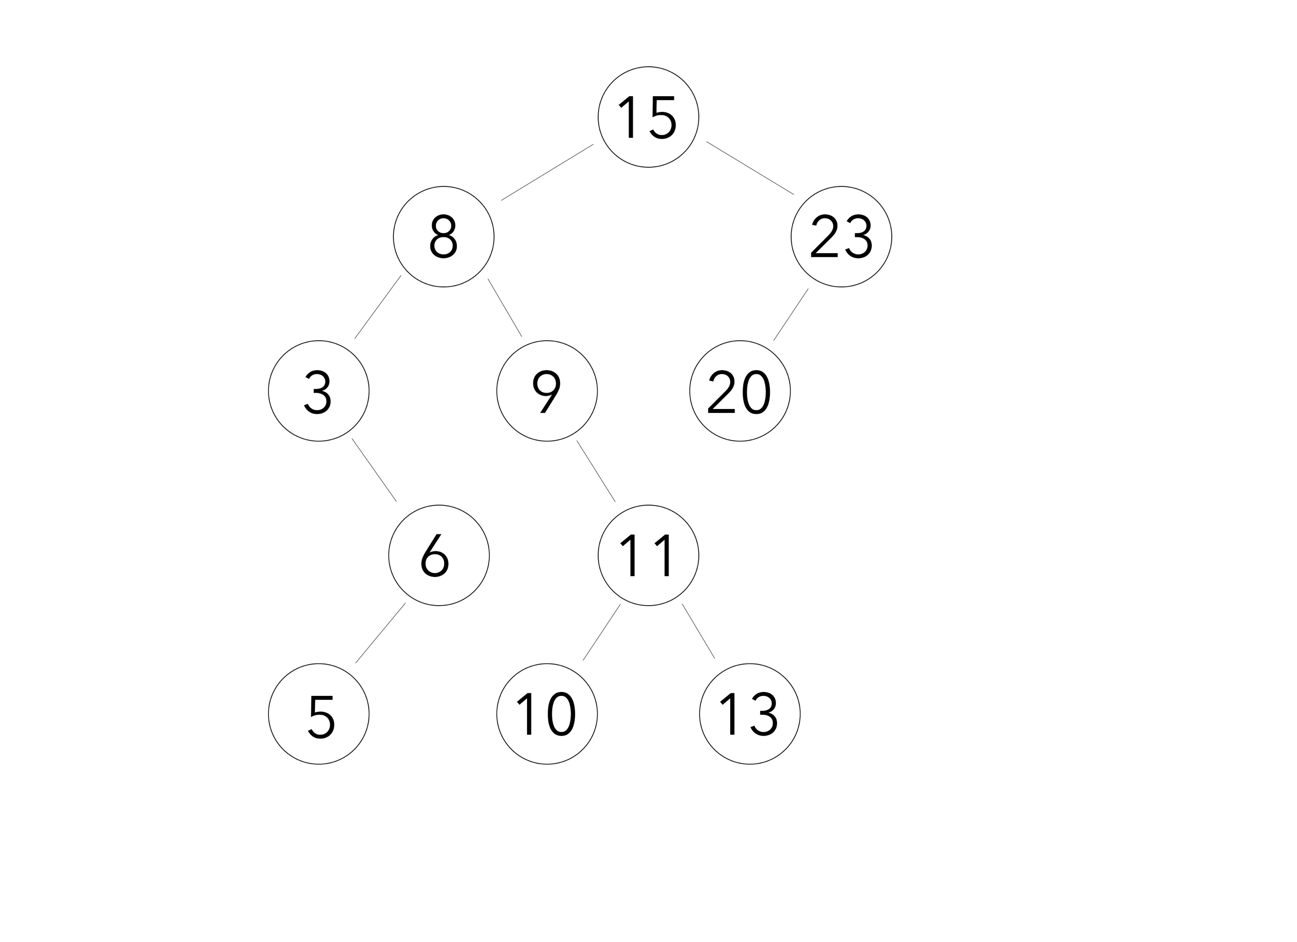

1. **What is the height of the resulting Binary Search Tree?**

4

1. **What is the depth of the node that stores the value 11?**

3

1. **Is there a path from the node storing the value 15 to the node storing the value 5? If so, show the path.**

Yes; 15 -> 8 -> 3 -> 6 -> 5.

1. **Is there a path from the node storing the value 8 to the node storing the value 20? If so, show the path.**

No.

1. **Is there a path from the node storing the value 8 to the node storing the value 10? If so, show the path.**

Yes; 8 -> 9 -> 11 -> 10.

1. **What is the largest possible height for a Binary Search Tree with 8 nodes?**

7

1. **What is the smallest possible height for a Binary Search Tree with 8 nodes?**

3

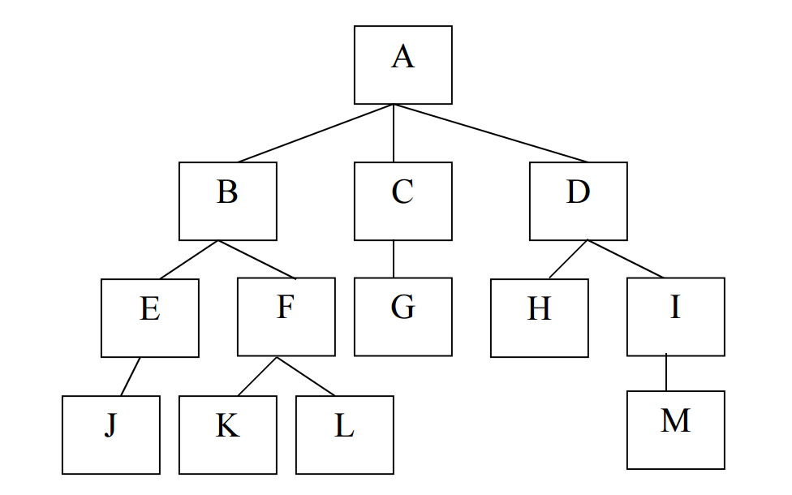

1. **List all internal nodes of the above tree.**

A,B,C,D,E,F,I.

1. **List all ancestors of node F.**

B,A.

1. **List all siblings of node F.**

K,L.

1. **List the nodes in the above tree in pre-order.**

A,B,E,J,F,K,L,C,G,D,H,I,M.

1. **List the nodes in the above tree in in-order.**

J,E,K,F,L,B,A,G,C,H,D,M,I.

1. **List the nodes in the above tree in post-order.**

J,E,K,L,F,B,G,C,H,M,I,D,A.